**ACTIVITY PERTEMUAN 2**

**NAMA : Aryasatya Dakara Putransyah**

**NPM : 50423219**

**KELAS : 3IA08**

**MATERI : HTML & CSS**

**MATA PRAKTIKUM : Pemrograman Web**

**(Screenshoot langkah-langkah sesuai video pembelajaran dan jelaskan dengan ringkas)**

**Membuat linktree**

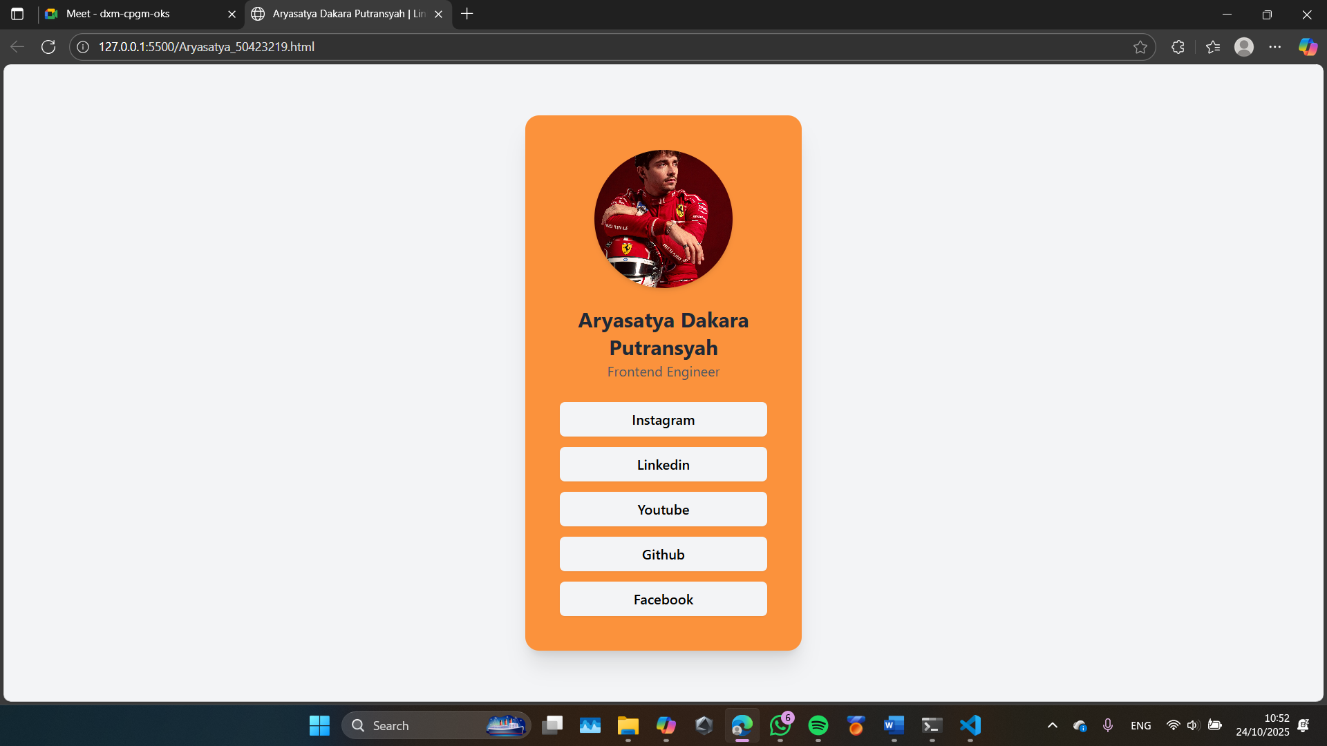<!DOCTYPE html>

<html lang="en">

<head>

    <meta charset="UTF-8">

    <meta name="viewport" content="width=device-width, initial-scale=1.0">

    <title>Aryasatya Dakara Putransyah | Linktree</title>

    <script src="https://cdn.tailwindcss.com"></script>

</head>

<body class="bg-gray-100 flex justify-center items-center min-h-screen">

      <section class="bg-orange-400 shadow-xl rounded-2xl p-10 w-80 flex flex-col items-center">

        <img class="w-40 h-40 rounded-full object-cover mb-5 shadow-md" src="https://destinationformula1.com/wp-content/uploads/2025/03/Charles-Leclerc-scaled.jpg" alt="charles">

        <h1 class="text-2xl text-gray-800 text-center font-bold">Aryasatya Dakara Putransyah</h1>

        <p class="text-gray-600 text-center mb-6">Frontend Engineer</p>

        <ul class="flex flex-col w-full gap-3 text-center">

            <li>

                <a href="instagram.com/dakaraputra" target="_blank" class="block bg-gray-100 hover:bg-orange-500 hover:text-gray-100 transition-all rounded-md py-2 font-medium shadow-sm">Instagram</a>

            </li>

            <li>

                <a href="https://www.linkedin.com/in/aryasatya-dakaraputra/" target="_blank" class="block bg-gray-100 hover:bg-orange-500 hover:text-gray-100 transition-all rounded-md py-2 font-medium shadow-sm">Linkedin</a>

            </li>

            <li>

                <a href="https://www.youtube.com/@dakaradkr" target="_blank" class="block bg-gray-100 hover:bg-orange-500 hover:text-gray-100 transition-all rounded-md py-2 font-medium shadow-sm">Youtube</a>

            </li>

            <li>

                <a href="https://github.com/Dakaraputra" target="_blank" class="block bg-gray-100 hover:bg-orange-500 hover:text-gray-100 transition-all rounded-md py-2 font-medium shadow-sm">Github</a>

            </li>

            <li>

                <a href="https://www.facebook.com/dakara.putra/" target="_blank" class="block bg-gray-100 hover:bg-orange-500 hover:text-gray-100 transition-all rounded-md py-2 font-medium shadow-sm">Facebook</a>

            </li>

        </ul>

      </section>

</body>

</html>